Format to report your ADVANCED JAVA PROGRAMMING PROJECTS
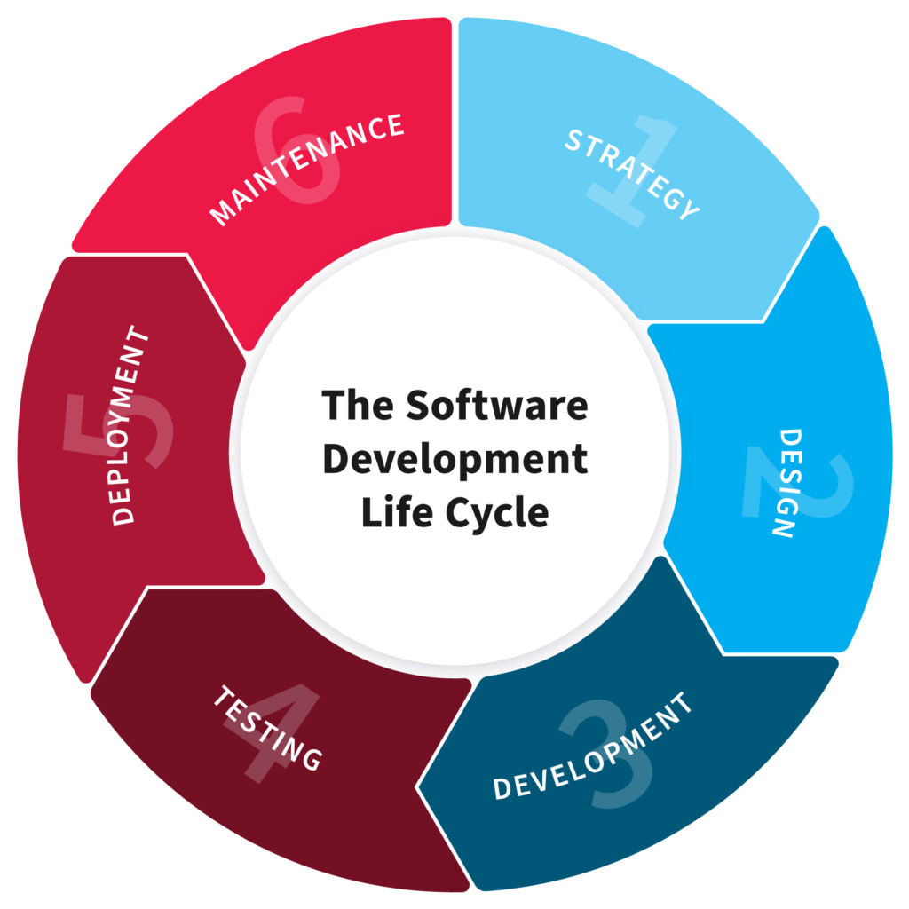

Names: MUGIRANEZA Gervais
Reg No: 221006464
Class Group: Group 2
Class No:38
Project Name: Hotel Management System

1.PLANNING

“In this Section, Students, have to define the system (your projects) goals and objectives and the problems the future system needs to solve.”

Firstly, Hotel Management system is a java web application project that will help you, the hotel owner, to manage their customer details that will save time and money and it may allow you to manage housekeeping and perform human
resources management as well. In general, HMS facilitates the main processes in a hotel that related to internal and external operations
as objective of Hotel Management System.
Admin user can manage all the activities performed by the user end such as to delete the hotel records, Add/Delete/Edit any user in the application. Admin can manage all the booked records as well.

the problems the future Hotel mNgent system needs to solve are the following:

- My system will solve of the problem of saving time because of no time needed to chech rooms that are free by moving from office to location only use system every where as admin.
- My sytem also solve the problem of saving money for controlling resources and customers information.
- It will solve problem of losting some data because we have database and saver where all data are saved etc,
- It will also solve problem money stolen from pocket because all customer pay money online for all wishes.
- Increasingly Facing Competition by using inventory and information management even umiquely services improved.
- Guest-Facing Technology: A Clear Call to Action should provide this technology, the other half prefers third-party suppliers to manage parts of the customer journey that help hotel for offering customers memorable uniquely services and good customer care play as customer is a king.
- To reduce line of cusromers services in long time taking record in books or note book as analog system.
- It help for reducing employees.
- Example: as analog system as customer you go to the hotel and go to services explain about what you want and sent to another employee who take record of employe and also sent to another where you pay money and sent to another who show your room booking it was Taking long time many employees.

Key functions of the reservation module include:

- Room bookings: The system checks room availability and status, shows free rooms across different channels and the website booking engine. This function monitors double bookings and allows group

- Reservations: Then it schedules bookings and displays information about current and upcoming
bookings on a dashboard.

- E-payments processing: Software collects online transactions and classifies them according to
their types and categories.

- Management of room inventory and allocation: Reservation tools prevent overbookings and double bookings. In some software, this function is part of a channel management module.

- Reservation emails: The system sends confirmations to guests after they complete their
booking. In some HMSs, this function is a part of the front-desk operations module.

- Activities booking: Some software allows guests to book not only accommodation but also
activities with this system.

2. Design

“In this Section, students’ needs to elaborate how the system will work, focusing on software design and how it works with the technical and functional requirements of the system. Depicts also how your team defined how users will interact with the software.”

System Requirements
Functional and non-functional criteria are the two types of requirements that the hotel management system must meet.

Functional Requirements
Booking / Reservation:

- Keep track of reservations.
- Keep track of the customer's first name.
- Keep track of the customer's last name.
- Keep track of the number of occupants.
- Keep track of the room number.
- Show the default room rate
- Make a note of the customer's phone number.
- Indicate whether the room is assured.
- Create a unique confirmation number for each transaction.
- Make a note of the anticipated check-in date and time.
- The system must keep track of the anticipated checkout date and time.
- Customers will be checked in by the system.
- The system must allow reservations to be changed without requiring the customer to resubmit all their information.
- Customers will be checked out by the system.

Use Case Diagram of Hotel Management System
This Use Case Diagram depicts the relationships between the pieces of the Hotel Management System graphically. It is the process used in system analysis to discover, clarify, and organize Hotel Management System requirements. The major components of the Hotel Management System UML use case diagram are depicted in the graphic below.

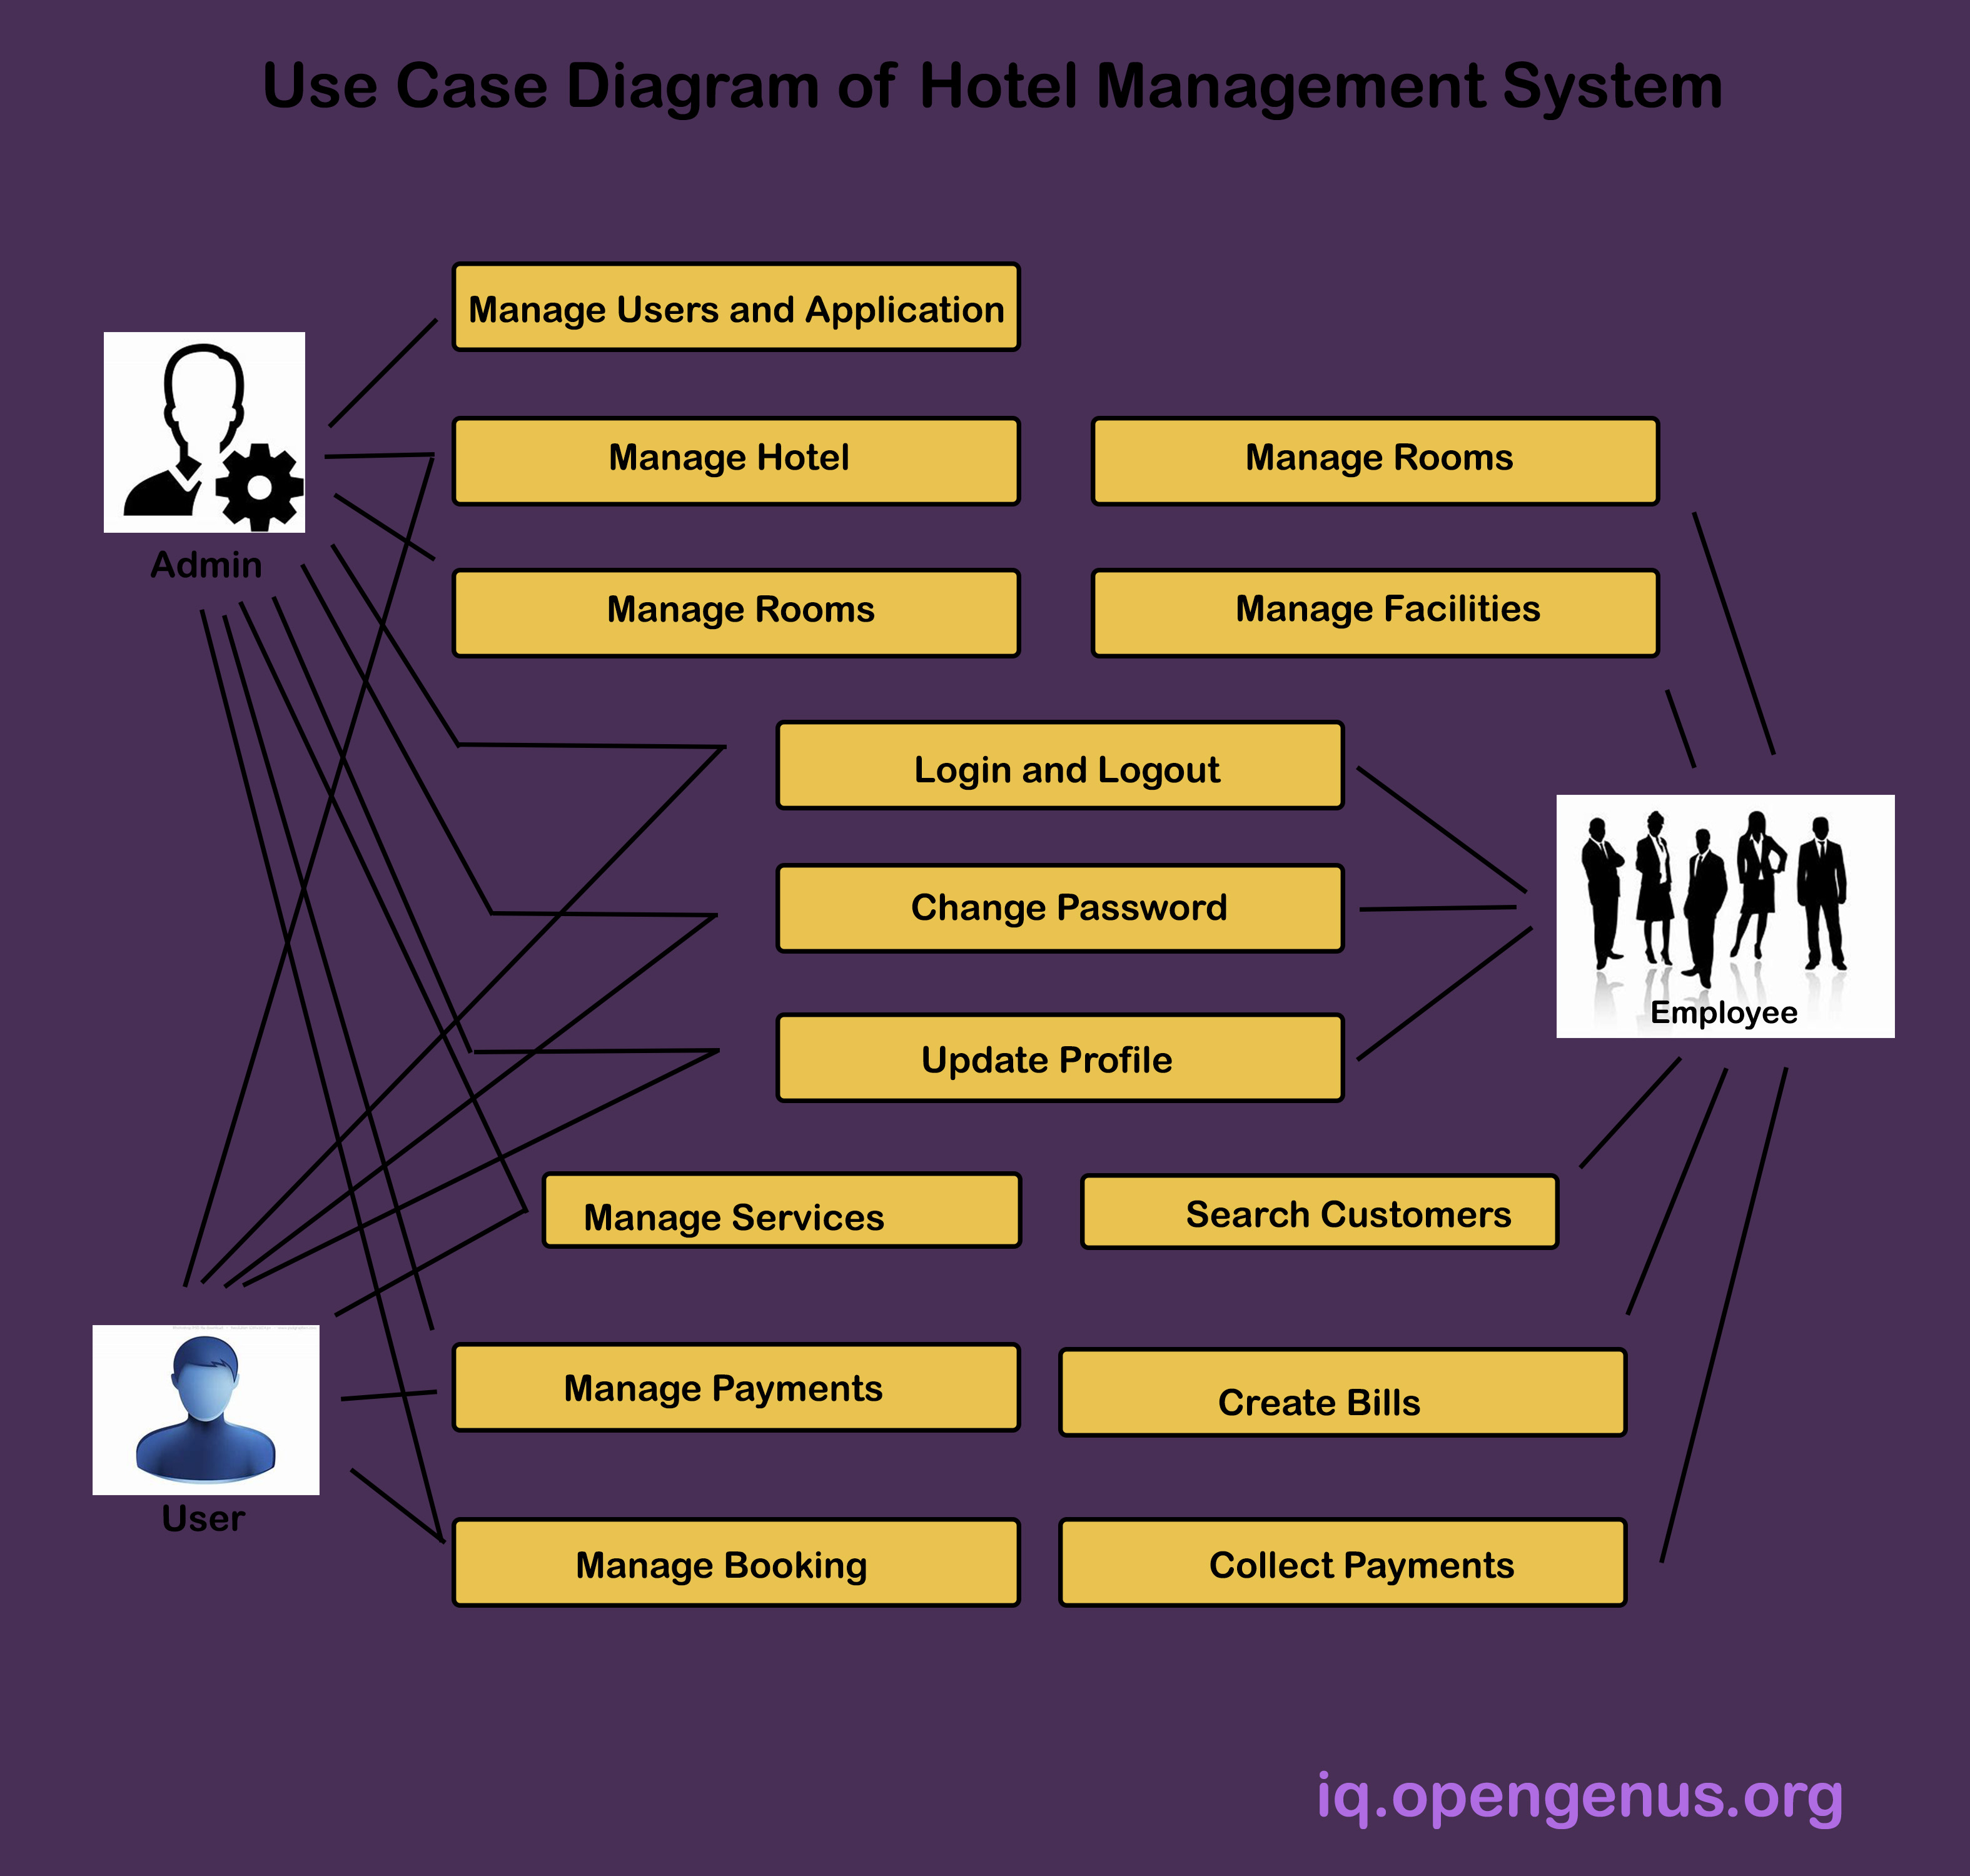

3. Development

“In this Section, Students need to elaborate how they build the entire system (Front end- back-end technologies), chosen libraries, platforms, storage and databases, adopted technologies, etc...”

To build this project we used java project and NetBeans IDE pc software application as text editor and jframes. Database we used is Xampp server, PHPmyadmin to record our data of our system and other library for dates we will provide website where we found other library we used that wasn’t built in the NetBeans IDE

4.Testing

“In this Section, Students to show the way this stage was conducted. Ensuring that everything works as expected. Which defects and bugs you found, and how did you fixed them to ensure that the product meets the original specifications.”

When building a hotel management system in Java, there are several types of bugs that may be encountered. Some common bugs that may be found include:

Syntax errors: These are errors that occur when the code is not written correctly and the Java compiler is unable to understand it. These errors can be fixed by reviewing the code and correcting any syntax errors.

Logical errors: These are errors that occur when the code is written correctly but the logic is not correct. For example, a function to calculate the total bill may be incorrect. Logical errors can be fixed by reviewing the code and identifying the incorrect logic, then correcting it.

Runtime errors: These are errors that occur when the code is executed and there is an issue with the runtime environment, such as a missing library or class. These errors can be fixed by reviewing the code and identifying the missing resource, then adding it to the environment.

Concurrency errors: These are errors that occur when multiple threads are accessing the same resource simultaneously, such as a database or file, and there is a conflict or race condition. These errors can be fixed by implementing proper synchronization techniques, such as using locks or semaphores, to control access to the shared resource.

Input validation errors: These are errors that occur when the system does not properly validate user input, such as allowing a user to enter negative numbers for a room rate. These errors can be fixed by implementing proper input validation checks in the code.

Security errors: These are errors that occur due to lack of proper security measures, such as not properly encrypting sensitive data. These errors can be fixed by implementing proper security measures, such as using encryption and secure authentication methods.

User interface errors: These are errors that occur in the user interface, such as buttons not working as intended or incorrect labels being displayed. These errors can be fixed by reviewing the user interface design and ensuring that it is functioning as intended.

It's important to have a thorough testing process in place to catch these bugs and fix them before the final release of the software.

5.Deployment

“In this Section, Students have to describe how, installation, testing, deployment, and performance monitoring were conducted in their own respective laptop or desktop. “

We have deployed our java project using pc software application called NetBeans IDE, the way you can Install it, is having the application we deployed and then run it as well.

The testing was playing great role, because we did get some difficulty about connect the application with database after deploying our application. But the good thing we found is the error was in our xampp database server as you can see.
It ensures that your code works as expected, every time it runs. Tests also function as documentation, giving an observer instructions on how to properly execute your classes and methods.
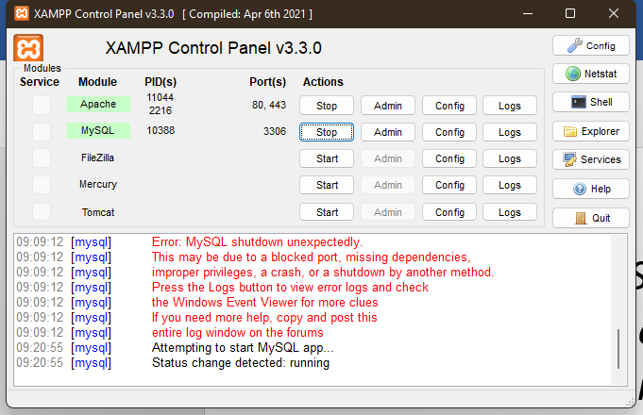
Mysql shutdown unexpectedly and I went on the internet to find help, and then fixed it, as you can see it below.
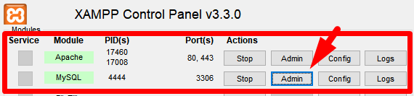

We did an ongoing performance monitoring daily, so that we can make sure that every error and bugs are well removed and now we have a well working pc application, if you want to use HOTEL MANAGEMNT SYSTEM, you just have to run it and run your business.

END

